ORCHID INTERNATIONAL COLLEGE

Tribhuvan University Faculties of Computer Science

Bachelors of Science in Computer Science and Information Technology
(BSc. CSIT)

Course: Numerical Method (CSC-207) Semester: III

A Lab Report On:

Numerical Differentiation & Integration

Submitted by:
Name: Aaryan Kushawaha Roll No: 28900/078
Submitted to:
Ganesh Thapa
Faculty, Department of Computer Science

LAB 3

TITLE: Numerical Differentiation & Integration OBJECTIVES :
- To study Differentiation & Integration methods used to find the value using provided reference data.

THEORY:

Derivatives using forward difference:

Concept:
- The concept of derivatives using the forward difference method is a numerical approach to estimate the derivative of a function at a particular point by calculating the slope of the secant line passing through that point and a neighboring point slightly ahead of it. This method is based on the definition of the derivative, which is the rate of change of a function with respect to its independent variable.
- The forward difference approximation of the derivative is defined as:
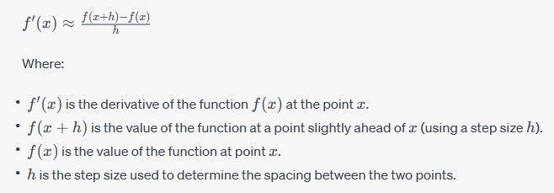

2

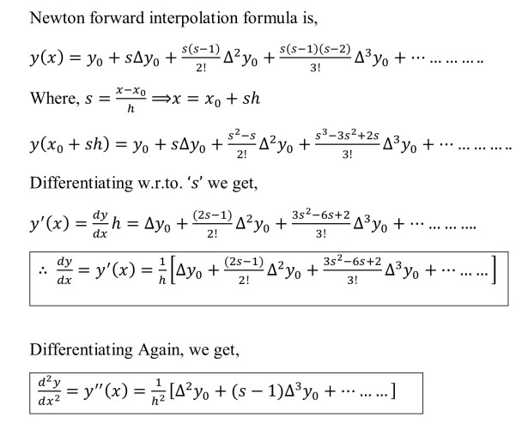
Formula:

Integration using Simpsons 1/3 rule:
Let, function f(x) pow(sin(x),0.5)

Concept:
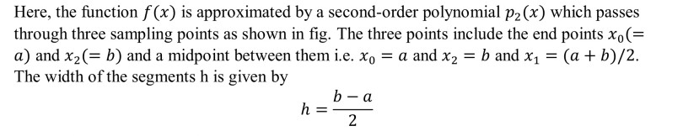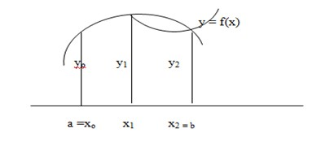⇨

3

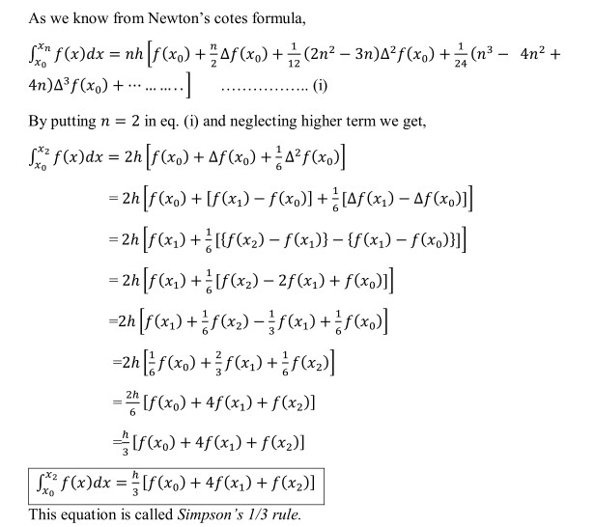

Integration using Simpsons 3/8 rule:

Concept:
- Simpson's 3/8 rule, also known as Simpson's Three-Eighths Rule, is a numerical integration technique used to approximate the definite integral of a function over a specified interval. It's an extension of the simpler Simpson's 1/3 rule and provides a way to estimate integrals when the number of subintervals is not divisible by 2 (i.e., when the number of intervals is not even). This rule offers higher accuracy than the 1/3 rule for a wider range of functions.

4

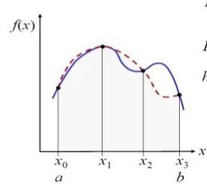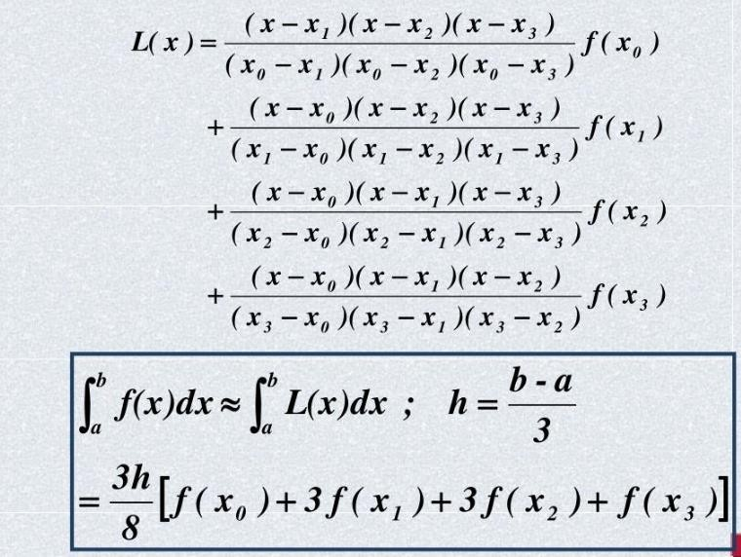

5

Integration using Trapeziodal rule :

Concept:
- Let , f(x) be the function X0 = a & X1 = b.
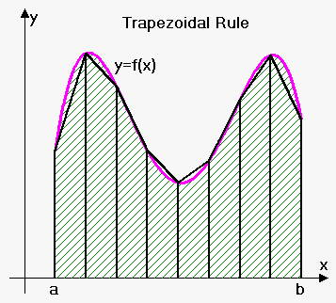

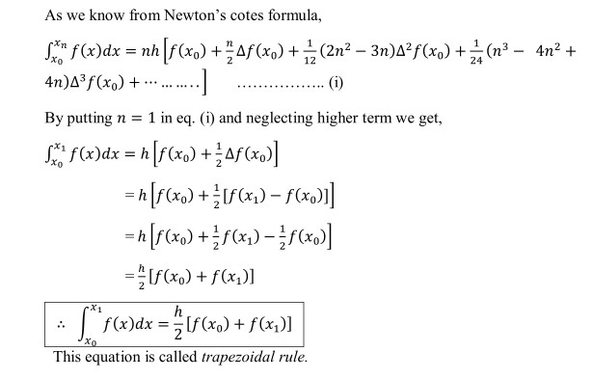h = X1– X0
6



PRACTICAL IMPLEMENTATION

TASK 1: Derivatives using forward difference

ALGORITHM :
- Start
- Read number of data (n)
- Read data points for x and y: For i = 0 to n-1
Read Xi and Yi,0 Next i
- Read calculation point where derivative is required (xp)
- Set variable flag to 0
- Check whether given point is valid data point or not. If it is valid point then get its position at variable index For i = 0 to n-1
If |xp - Xi| < 0.0001 index = i
flag = 1
break from loop End If

Next i
- If given calculation point (xp) is not in x-data then terminate the process.
If flag = 0
Print "Invalid Calculation Point" Exit
End If
- Generate forward difference table For i = 1 to n-1
For j = 0 to n-1-i Yj,i = Yj+1,i-1 - Yj,i-1
Next j Next i
- Calculate finite difference: h = X1 - X0
- Set sum = 0 and sign = 1

7

- Calculate sum of different terms in formula to find derivatives using Newton's forward difference formula:
For i = 1 to n-1-index term = (Yindex, i)i / i
sum = sum + sign * term sign = -sign
Next i
- Divide sum by finite difference (h) to get result first_derivative = sum/h
- Display value of first_derivative
- Stop

8

OUTPUT :-
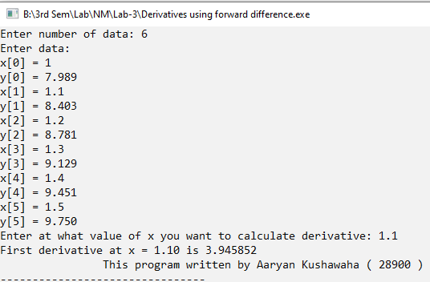

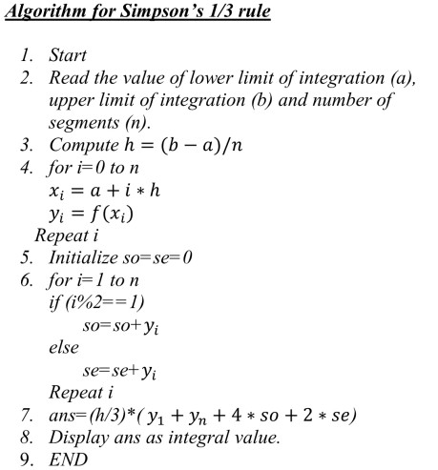
TASK 2: Integration using Simpsons 1/3 rule

9

Output :-
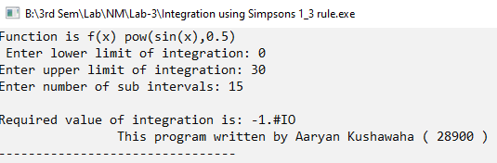

TASK 3: Integration using Simpsons 3/8 rule

ALGORITHM:
- Start
- Define function f(x)
- Read lower limit of integration, upper limit of integration and number of sub interval
- Calcultae: step size = (upper limit - lower limit)/number of sub interval
- Set: integration value = f(lower limit) + f(upper limit)
- Set: i = 1
- If i > number of sub interval then goto
- Calculate: k = lower limit + i * h
- If i mod 3 =0 then
Integration value = Integration Value + 2* f(k) Otherwise
Integration Value = Integration Value + 3 * f(k) End If
- Increment i by 1 i.e. i = i+1 and go to step 7
- Calculate: Integration value = Integration value * step size*3/8
- Display Integration value as required answer
- Stop

10

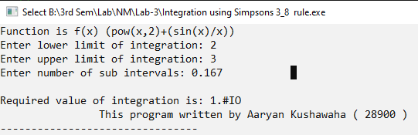
OUTPUT:

TASK 4 : Integration using Trapeziodal rule

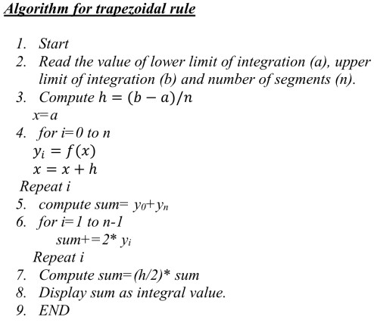

11



OUTPUT:

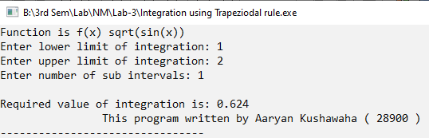

CONCLUSION:
➔Program to implement solving the Derivative using forward difference , integration Simpson 1/3 , 3/8 & Integration using trapeziodal Rule using C Language , were written using High level language & Respective output of each program . Therefore , all results were satisfied by the program.

12

